Sebring 46 BXN
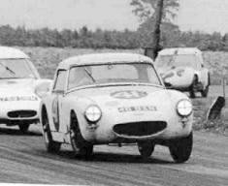

Peter Jackson competed in his white Sebring Sprite successfully in 1961 . .

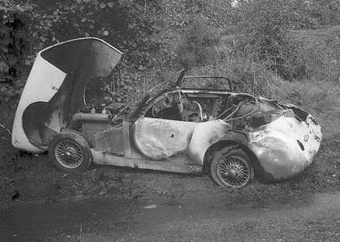

Until an electrical fault during a Welsh rally started a terminal fire . .

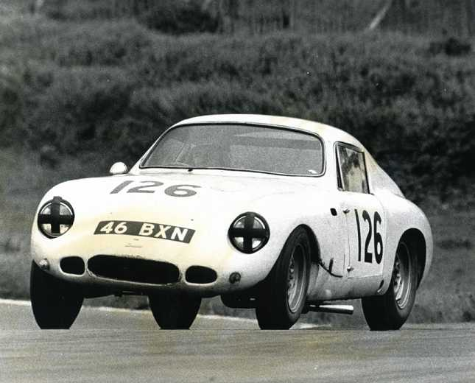

Peter chose to re-body the car using Peel’s of Kingston, and with design input from DW-S . .

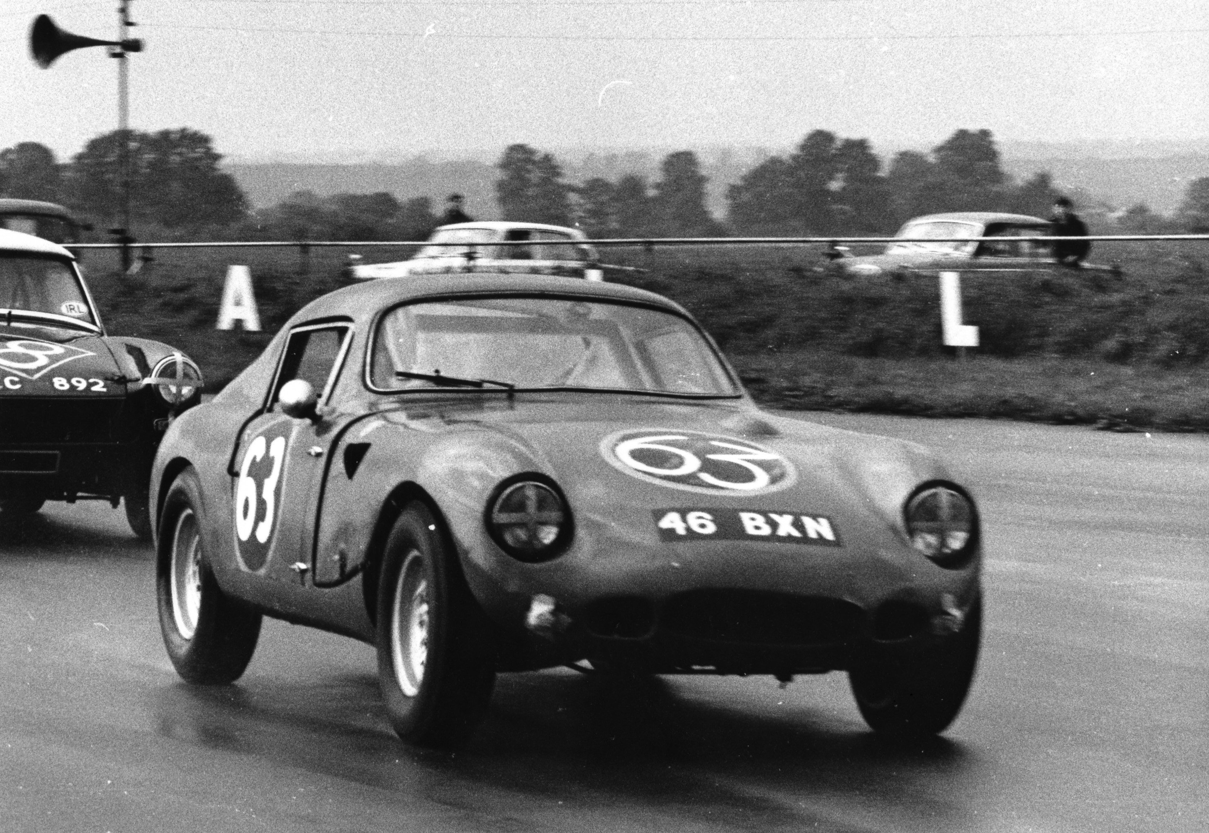

Next owner Richard Higgins changed the colour to red in the 1970’s . .

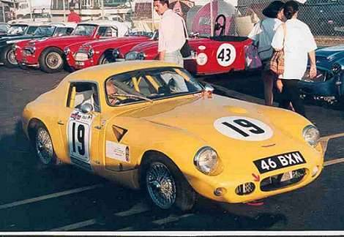

Stuart Radnofsky repainted yellow and sold the car to Mick Darcey in 1994. In 1995 the car featured at Silverstone Coys Historic . .

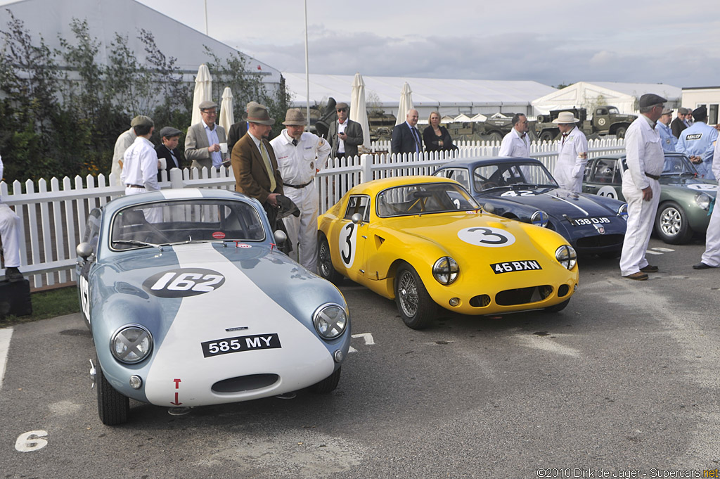

Paul Woolmer bought the car in 2006. Goodwood Revival entry and HRDC races since have brought success . .

